Case Study 1: Smart Healthcare System using Bayesian Belief Networks
Title:
Real-Time Patient Monitoring using Bayesian Belief Networks and Probability Learning
Problem Statement
Hospitals and healthcare providers require continuous monitoring of patients' vital signs to detect medical emergencies early. Wearable sensors collect physiological data such as heart rate, body temperature, blood pressure, oxygen saturation (SpO₂), and respiratory rate. However, sensor readings may contain noise, missing values, or errors. Bayesian Belief Networks (BBNs) provide an efficient probabilistic framework for handling uncertainty and improving anomaly detection.
Objective
- Monitor patient health continuously.
- Detect abnormal health conditions in real time.
- Handle uncertain or noisy sensor data.
- Reduce false alarms.
- Support doctors with reliable decision-making.
Parameters Used
- Heart Rate (HR)
- Blood Pressure (BP)
- Body Temperature
- Oxygen Saturation (SpO₂)
- Respiratory Rate
- ECG Signal
- Patient Activity Level
Bayesian Belief Network Model
The Bayesian network represents relationships among physiological parameters.

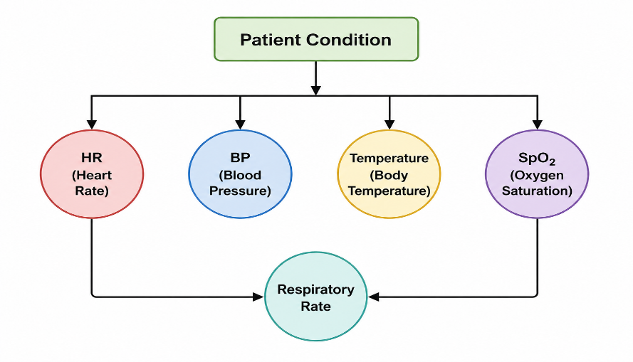
Each node represents a random variable.
Example:
- Fever increases heart rate.
- Low SpO₂ affects respiratory rate.
- High blood pressure increases heart disease risk.
Conditional Dependencies
Instead of treating every parameter independently, Bayesian Networks model dependencies.
Example:
P(Heart Disease | BP, HR, ECG)
If
- BP = High
- HR = High
- ECG = Abnormal
then
Probability of heart disease becomes very high.
Handling Sensor Noise
Wearable sensors may produce
- Missing readings
- Motion artifacts
- Battery issues
- Wireless transmission errors
Bayesian inference estimates the missing values using probabilities.
Example:
If
SpO₂ sensor fails
the system estimates oxygen level from
- Heart Rate
- Respiratory Rate
- Previous measurements
Thus monitoring continues without interruption.
Probability Learning
Historical patient records are used.
Training Data:
Heart Rate
Blood Pressure
Temperature
Diagnosis
The algorithm learns
P(Fever | Temperature)
P(Heart Disease | BP, ECG)
using previous medical records.
System Workflow

Performance Evaluation
Evaluation Metrics
- Accuracy
- Precision
- Recall
- F1 Score
- Detection Time
- False Alarm Rate
Example Results
Metric | Value
Accuracy | 96%
Precision | 95%
Recall | 94%
F1 Score | 94.5%
False Alarm Rate | 3%

Advantages
- Handles uncertain information.
- Detects anomalies early.
- Supports real-time monitoring.
- Works even with missing sensor values.
- Provides interpretable decisions.
Challenges
- Sensor calibration errors.
- High computational cost.
- Large training dataset required.
- Privacy and security concerns.
- Battery limitations in wearable devices.
Conclusion
Bayesian Belief Networks provide an effective framework for smart healthcare monitoring. They accurately model relationships among physiological parameters while handling uncertainty caused by noisy sensors. The system improves patient safety through early anomaly detection and reliable clinical decision support.

Case Study 2: Cybersecurity using Naïve Bayes, EM Algorithm and Bayesian Learning
Title:
Probabilistic Network Intrusion Detection using Bayesian Learning
Problem Statement
Modern computer networks face cyberattacks such as malware, phishing, DDoS attacks, and unauthorized access. Traditional intrusion detection systems often produce many false alarms. Probabilistic learning methods like Naïve Bayes, Expectation-Maximization (EM), and Bayesian learning help classify network traffic more accurately, even when data is incomplete.
Objective
- Detect malicious network traffic.
- Classify normal and abnormal behavior.
- Reduce false alarms.
- Handle missing or incomplete data.
- Adapt to changing attack patterns.
Input Features
- Source IP
- Destination IP
- Port Number
- Packet Size
- Protocol
- Login Attempts
- Traffic Volume
- Session Duration
Naïve Bayes Classifier
Naïve Bayes assumes all features are independent.
Formula
P(Class|Features) ∝ P(Class) ×P(Feature1|Class)×P(Feature2|Class)...
Example
Features
- Large packet size
- Unknown IP
- Multiple login failures
The classifier calculates
P(Attack)
P(Normal)
The larger probability determines the class.
EM Algorithm
Some network traffic labels may be missing.
The EM algorithm performs two steps.
Expectation Step
Estimate hidden labels.
Example
Unknown traffic is estimated as
80% Normal
20% Attack
Maximization Step
Update probability distributions.
Repeat until convergence.
This improves classification even without fully labeled datasets.
Bayesian Learning
Bayesian learning updates attack probabilities as new data arrives.
Example
The model continuously improves detection performance.
Handling Hidden Patterns
Hidden attacks include
- Zero-day attacks
- Insider threats
- Unknown malware
EM discovers hidden clusters within network traffic.
Thus new attack patterns become detectable.
System Workflow

Performance Evaluation
Metric | Value
Accuracy | 97%
Precision | 96%
Recall | 95%
F1 Score | 95.5%
False Positive Rate | 2%

Advantages
- Fast classification.
- Learns continuously.
- Handles incomplete datasets.
- Reduces false alarms.
- Detects hidden attack patterns.
Challenges
- Assumption of feature independence.
- Highly dynamic attack methods.
- Imbalanced datasets.
- Large-scale network traffic.
- Real-time computational requirements.
Conclusion
The combination of Naïve Bayes, EM algorithm, and Bayesian learning significantly improves intrusion detection accuracy. It adapts to changing cyber threats while effectively handling hidden patterns and incomplete network data.

Case Study 3: Crop Yield Prediction using Bayesian Inference
Title
Crop Yield Prediction under Uncertain Environmental Conditions using Bayesian Inference
Problem Statement
Agricultural productivity depends on uncertain environmental factors such as rainfall, soil quality, humidity, and temperature. Farmers need reliable predictions to plan irrigation, fertilizer use, and harvesting. Bayesian inference combines historical agricultural data with current environmental conditions to estimate crop yield.
Objective
- Predict crop yield accurately.
- Handle uncertain weather conditions.
- Support farming decisions.
- Improve food production planning.
- Assist government policy decisions.
Input Parameters
- Rainfall
- Soil Quality
- Temperature
- Humidity
- Fertilizer Usage
- Crop Variety
- Irrigation Availability
Bayesian Inference
Bayes' Theorem
P(Yield | Weather) =P(Weather | Yield)×P(Yield)/P(Weather)
Where
Prior
Historical crop production.
Likelihood
Current environmental observations.
Posterior
Updated crop yield prediction.
Prior Agricultural Knowledge
Historical information includes
- Previous crop yields
- Seasonal rainfall
- Soil fertility
- Fertilizer usage
- Crop disease history
Example
Average Rice Yield=4 tons/hectare
This becomes the prior probability.
Seasonal Variations
Weather changes every season.
For example
Good rainfall
↓
Higher crop probability
Poor rainfall
↓
Lower crop probability
Bayesian learning continuously updates predictions.
Predictive Workflow
Historical Data+Current Weather
↓
Bayesian Inference
↓
Probability Update
↓
Crop Yield Prediction
↓
Farmer Recommendation

Decision Support
Farmers receive recommendations such as
- Irrigation scheduling
- Fertilizer application
- Crop selection
- Harvest timing
Government agencies can use predictions for
- Food supply planning
- Crop insurance
- Drought management
- Resource allocation
Performance Evaluation
Metric | Value
Prediction Accuracy | 93%
RMSE | Low
Precision | 92%
Recall | 91%
Reliability | High

Advantages
- Handles uncertain environmental conditions.
- Uses historical agricultural knowledge.
- Supports precision farming.
- Improves resource management.
- Helps policymakers plan food production.
Challenges
- Climate change affects prediction accuracy.
- Limited historical datasets.
- Sensor inaccuracies.
- Regional soil variations.
- Computational complexity for large datasets.
Conclusion
Bayesian inference provides a reliable framework for crop yield prediction by combining historical agricultural knowledge with real-time environmental data. The model improves farming decisions, supports government planning, and enhances agricultural productivity under uncertain conditions.

